Step 1.

All daemons should run.

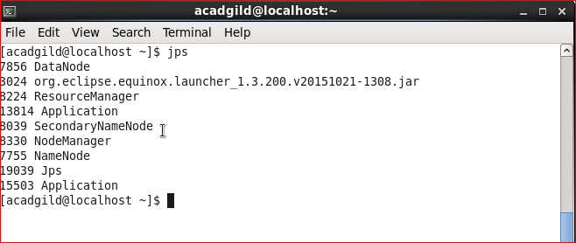

Step 2.

Configuration file should be at below mention path.

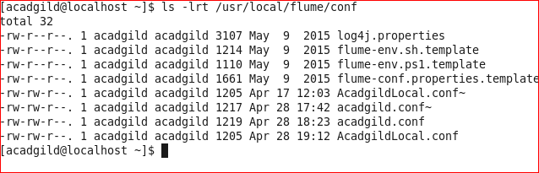

Step 3.

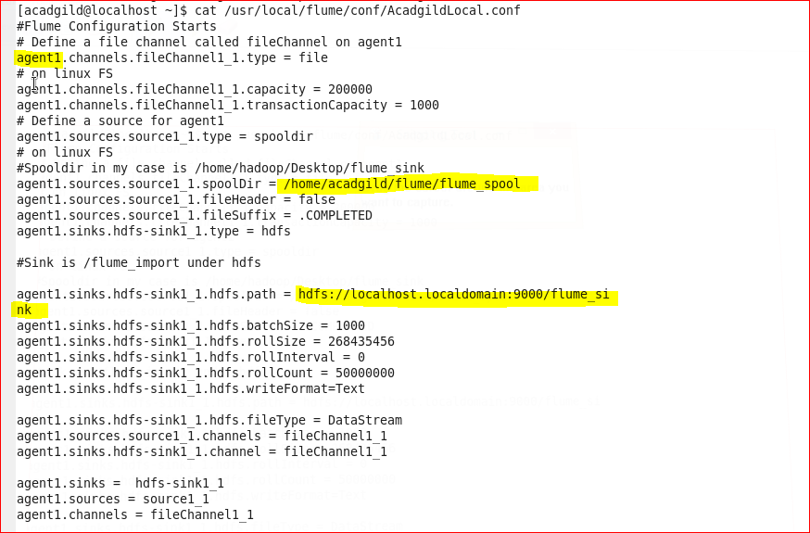

Step 4.

Source directory.

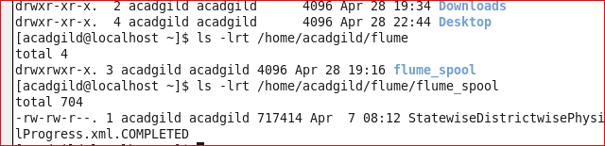

Step 5.

Output directory.

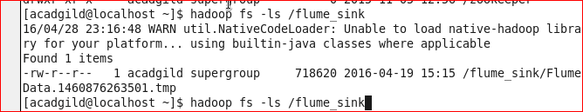

Step 6.

Flume Command.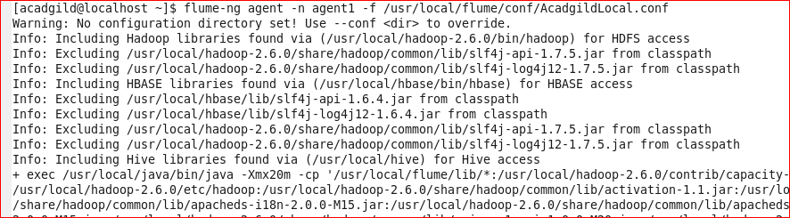

Step 7.

Flume running.

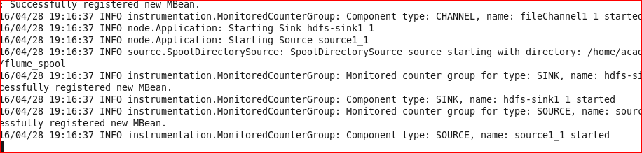

Step 8.

Output

